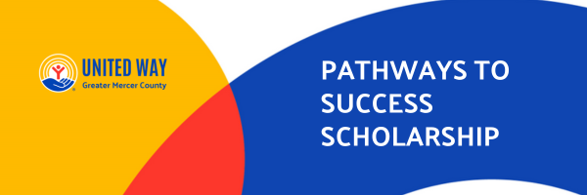

United Way of Greater Mercer County is proud to introduce our Pathways to Success Scholarship Program, designed to support ambitious high school students who are ready to take the next step toward their future. Whether the goal is college or trade school, this scholarship celebrates the diverse talent and aspirations of our Mercer County Youth.
Eligibility: To qualify for the PTSS, students must meet the following criteria
1. Minimum GPA: 2.5 on a 4.0 scale
2. Residency: Must reside in Mercer County
3. Education Goals: Planning to attend a college, university, or accredited trade school

Scholarship Details:
Award Amount: $1000.00 (5 scholarships will be awarded)
Application Deadline: May 1, 2025
Notification Date: Recipients will be notified no later than June 1, 2025
Recipients must be available for a small reception in June.
Application Requirements:
1. Completed Application Form
2. Proof of Mercer County Residency (e.g. School ID or Driver's License)
3. Academic Transcript - GPA of 2.5 or higher sent to PTSS@uwgmc.org
4. 500 Word essay: Describe a challenge you have faced and how it shaped your definition of success. How will achieving your educational or career goals help you make a positive impact in your community?

At United Way of Greater Mercer County, we are committed to protecting the privacy and confidentiality of all applicants. Any personal information provided on the scholarship application, including but not limited to name, contact details, financial information, and academic records, will be used solely for the purpose of evaluating eligibility and awarding scholarships. We do not share, sell, or distribute applicant information to third parties without explicit consent, except as required by law. All application materials will be handled with the utmost care and stored securely to prevent unauthorized access. By submitting a scholarship application, applicants acknowledge and agree that their information will be reviewed by the scholarship selection committee and relevant administrators for evaluation purposes only. If you have any questions regarding the confidentiality of your information, please contact Fatima Scipio at Fatima.Scipio@uwgmc.org.
United Way of Greater Mercer County Pathways to Success Scholarship Application

Student Information:
Student’s Name
Student’s Address
City, State, Zip
Email Address
Cell Phone # |  | Date of Birth
I participated in the United Way of Greater Mercer County Pathways to Success: College and Career Readiness Program. |  |  |  | Y or N

High School Education Information:
Name of school where you will receive your high school diploma or GED

Anticipated Graduation Date |  | High School GPA

Post High School Information:
Name of College/University/Trade School you will be attending:

Type of Educational Institution named above Mark with an “X” |  |  | Community College
 |  |  | College/University
 |  |  | Trade School
Anticipated Major/Field of Study

Required Attachments:
Completed Application Form
500 Word Essay: Describe a challenge you have faced and how it shaped your definition of success. How will achieving your educational or career goals help you make a positive impact in your community?
Academic Transcript - GPA of 2.5 or higher
Proof of Mercer County Residency (e.g. School ID or Driver's License)

Submit Via Email to PTSS@uwgmc.org, Subject: PTS Scholarship
Or Mail to
United Way of Greater Mercer County
Attn: Scholarship
3444 Quakerbridge Road, Bldg 3, Suite 101
Hamilton, NJ 08619

